2019-01-30

Seeder aan Runners toevoegen

Tabel runners maken:

Php artisan make:model Runner -a

Volgende php wordt aangemaakt, voeg hier de velden toe.

c:\share\laravel\www\database\migrations\2019_01_29_144835_create_runners_table.php

<?php

use Illuminate\Support\Facades\Schema;

use Illuminate\Database\Schema\Blueprint;

use Illuminate\Database\Migrations\Migration;

class CreateRunnersTable extends Migration

{

/**

* Run the migrations.

*

* @return void

*/

public function up()

{

Schema::create('runners', function (Blueprint $table) {

$table->increments('id');

$table->timestamps();

$table->string('naam');

$table->string('email');

$table->unsignedInteger('afstand');

$table->unsignedInteger('aantal');

});

}

/**

* Reverse the migrations.

*

* @return void

*/

public function down()

{

Schema::dropIfExists('runners');

}

}

Om velden te kunnen toevoegen volgende php aanpassen

c:\share\laravel\www\app\Runner.php

<?php

namespace App;

use Illuminate\Database\Eloquent\Model;

class Runner extends Model

{

//

protected $fillable = ['naam', 'email', 'afstand', 'aantal'];

}

Seeder maken



RunnersTableSeeder.php wordt aangemaakt

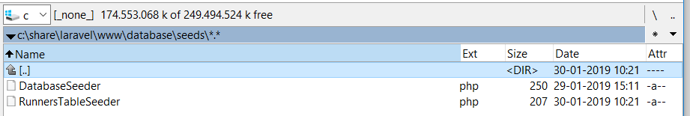

Voeg velden toe aan table runners

<?php

use Illuminate\Database\Seeder;

class RunnersTableSeeder extends Seeder

{

/**

* Run the database seeds.

*

* @return void

*/

//

public function run()

{

DB::table('runners')->insert(

[

['naam' => 'Henkpenkie',

'email' => 'henkpenkie@henk.nl',

'afstand'=> 7,

'aantal' => 3,

],

['naam' => 'Ernie' ,

'email' => 'ernie@ernie.nl',

'afstand'=> 8,

'aantal' => 4,

],

['naam' => 'Bert' ,

'email' => 'Bert@bert.nl',

'afstand'=> 8,

'aantal' => 4,

]

]);

}

//

}

Breid volgende php uit:

c:\share\laravel\www\database\seeds\DatabaseSeeder.php

<?php

use Illuminate\Database\Seeder;

class DatabaseSeeder extends Seeder

{

/**

* Seed the application's database.

*

* @return void

*/

public function run()

{

// $this->call(UsersTableSeeder::class);

$this->call(RunnersTableSeeder::class);

}

}

Php artisan migrate:refresh --seed

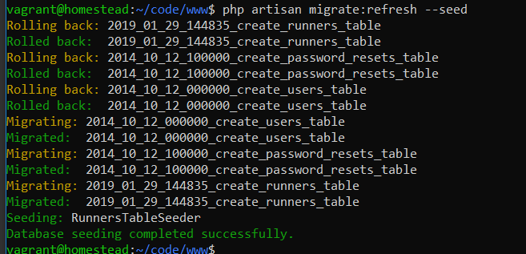

Mysql openen en database homestead openenen:

